Date:07/01/23

***Q. Write a program to find the table of a number.(for loop)***

int main()

{

int num,c,i;

printf("enter the number for table print");

scanf("%d",&num);

for

(i=1;i<=10;i++)

{

c=num*i ;

printf("%d*%d=%d\n",num,i,c);

}

return 0;

}

***Output:***

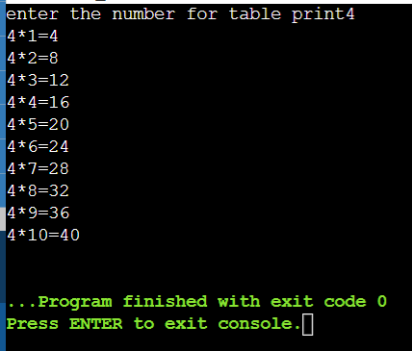

***Algorithm:***

***Step 1:*** Start

***Step 2:*** declaration(num,c,i)

***Step 3:*** input a number

***Step 4:*** use for loop condition(i=1;i<=10;i++)

***Step 5:*** c= num*i

***Step 6:*** display c

***Step 7:*** if i<=10 true then repeat the step 5 and continued the condition till i=10, if false then go to

the step 6

***Step 8:*** end